A side of the Negev that only African migrants see

Photographer Ron Amir’s first Israel Museum exhibit, ‘Doing Time in Holot,’ shows daily life for 3,300 would-be refugees at Israel’s desert detention center
By Jessica Steinberg 26 February 2017, 12:40 pm 2
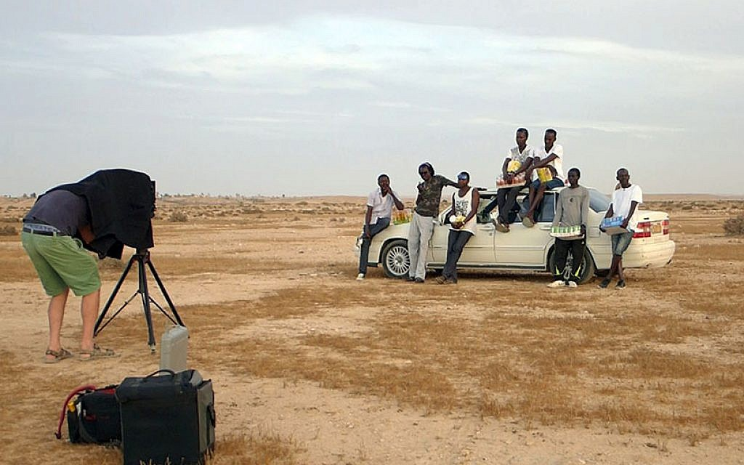
From a video work in 'Doing Time at Holot,' Ron Amir's first Israel Museum exhibit currently on display (Courtesy Israel Museum)
The Holot Detention Facility in the Negev, where Eritrean and Sudanese asylum seekers are held for months on end, is a place where Israelis don’t visit, nor know much about. That’s one of the reasons why photographer Ron Amir spent three years documenting aspects of life there, now presented in “Doing Time in Holot,” his first exhibit for the Israel Museum.
“It’s not the Negev that Israelis know,” said Noam Gal, the curator of the exhibit who frequently traveled with Amir to the desert detention facility over the course of two years, to gain a better understanding of the people and place.
“It’s not pastoral, it’s straight, dirty, boring desert,” he said. “You can walk kilometers without seeing anything.”
There are some 45,000 Eritreans and Sudanese in Israel, according to Assaf, the Aid Organization for Refugees and Asylum Seekers in Israel, and space for 3,300 detainees at Holot. The detention center, which is called an open facility, is operated by the Israeli Prison Service.
They can be sent to the detention center for three to twelve months and then get sent back to wherever they were, Tel Aviv, Herzliya, Jerusalem, with no reasoning behind the decision to send them to Holot and then back to Israel proper, said Gal.
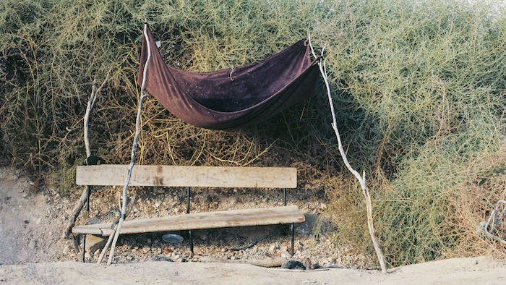
‘Abderazik’s Bench,’ 2014 by Ron Amir, from ‘Doing Time at Holot’ (Courtesy Israel Museum)
While at Holot, they are given plastic identification cards and can leave the facility at 6 a.m. after roll-coll and then return at 10 p.m., spending their days wandering around the empty desert flats of garbage-strewn sand.
“It’s a place with no rules, and that’s the agenda,” said Gal.
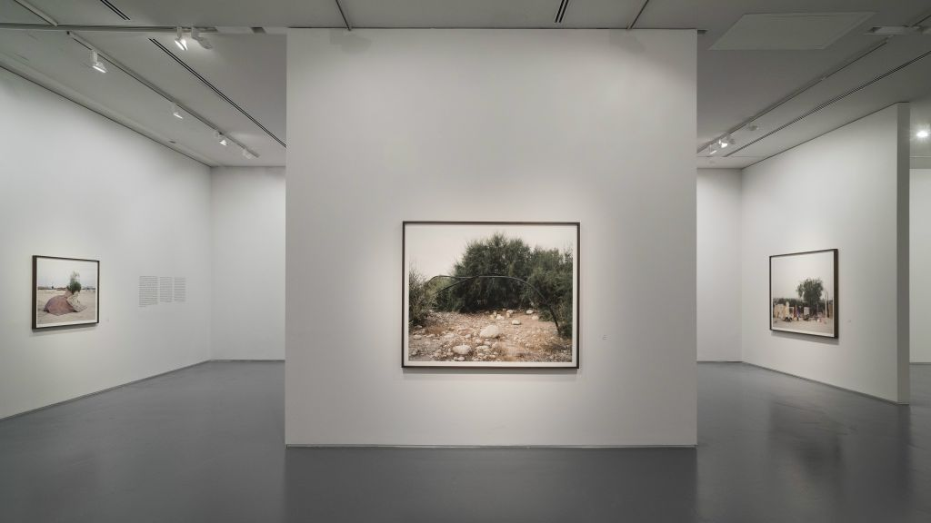
Building a roof from what’s found in the empty desert at the Holot Detention Center, a work by Ron Amir at his Israel Museum exhibit, ‘Doing Time in Holot’ (Courtesy Israel Museum)
It was that emptiness and lack of structure that Amir, a skilled photographer, aimed to document with a series of photographs and videos presented in the exhibit. Amir’s large, oversized photographs don’t feature any people, but rather focus on the area outside the facility where the detainees spend their days.
In between the photographs on display at the museum are several small screens, showing short and longer videos of the detainees themselves, sometimes talking to the camera, and at other times documented as they talk to one another.
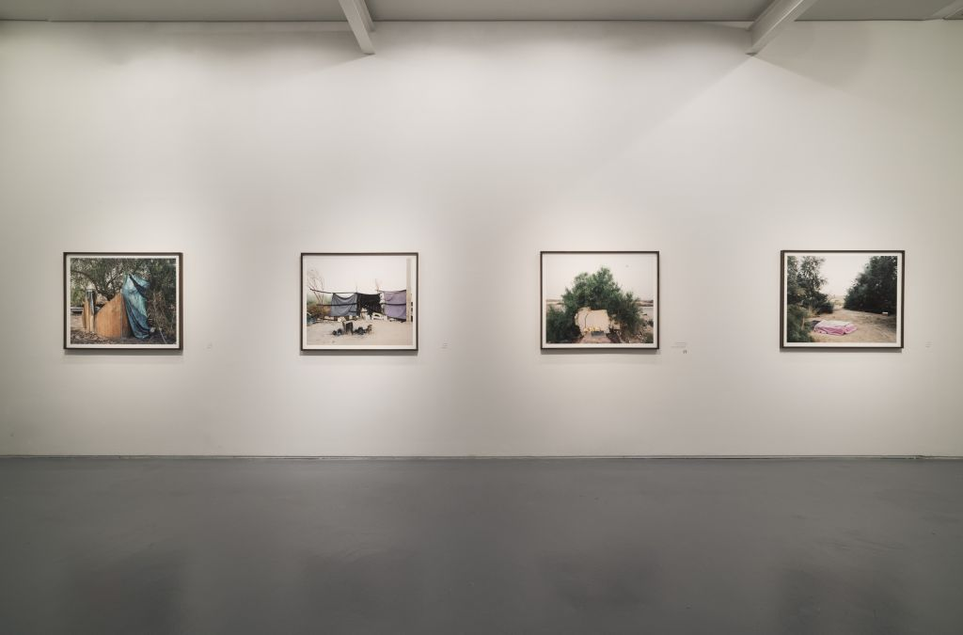
Makeshift dining areas and cooking spaces in the desert outside Holot, captured by Ron Amir in ‘Doing Time in Holot’ (Courtesy Israel Museum)
“Ron brings us something that is different from how you photograph social issues of people and their difficult situations,” said Gal. “You don’t see the people, you don’t see the facility. Difficult things happen there and you don’t see it in his photographs. He’s a documentarian doing contemporary art, and he lets you see problematically beautiful things.”
As the photographs attest, the detainees have storage pits and makeshift gyms, coffee bars where they prepare coffee and tea, and plots of sorghum, a grass that is grown for its grain and which is native to Africa. There are also shot of communal dining areas in the desert, where overturned, empty tin cans and broken pieces of wood become crude benches and tables.
These featured piles of detritus that are found, rescued and put to use become a sign that the detainees have something of their own, said Gal. “These piles are theirs and people know it as such. It’s a charged thing to say they have something of their own.”

Ron Amir (Courtesy Ron Amir)
Amir, the artist who first spent long hours with the detainees before bringing his equipment to document their lives in Holot, has shifted his focus from art to activism.
“He’s very stubborn on drawing a clear line between being an activist and being an artist,” Gal said. “When he wakes up in the morning and takes his cameras and car and drives down to Holot, he doesn’t have any idea about making art out of it. He just feels he has to go out and know these people and let them talk to him and he wants to hear their story and make it transparent to the Israeli public.”
His motivation, however, is not necessarily to create change in the situation, but rather to document it and bring it to the public’s attention.
On the opening night of the exhibit, the refugees featured in the exhibit were invited and, unplanned, grabbed people by the hand and showed them what was featured in each photograph.
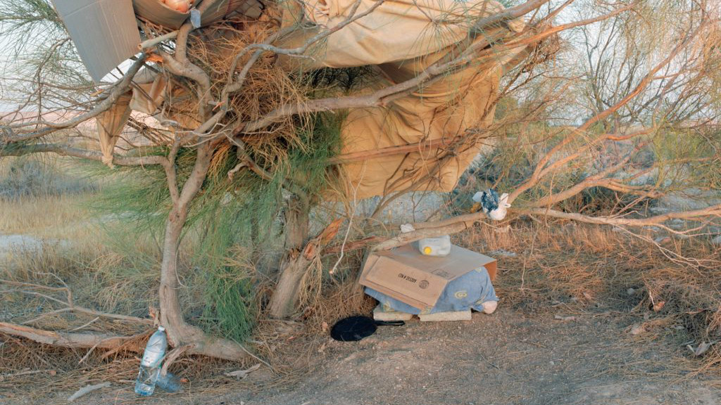
Ron Amir’s ‘Kitchen, Front View’ from ‘Doing Time at Holot,’ now at the Israel Museum (Courtesy Israel Museum)
“The guests thought they were the guides to the exhibit,” said Gal.
They weren’t, but he sees that example as an incentive for viewers to stop and look carefully at each photograph, in an attempt to see all the images featured in each frame.
“The longer time you’ll take in front of one image, the more things and meanings you’ll see,” he said.
Ron Amir’s “Doing Time in Holot” exhibition runs through April 22 at the Israel Museum.

Amar’e Stoudemire completes his conversion to Judaism
You Might Also like

Sea of Galilee water level at 27-year high for early September

Suspected pipeline attack leads to blackout across Syria

‘Hotel Rwanda’ hero arrested on terror charges, say police

Thousands of Palestinians enter Israel, head to beaches; soldiers turn blind eye
Sponsored Content

Sponsored IBM Watson Assistant - Delivers fast, accurate answers around COVID-19 IBM

Sponsored Discover the Most Expensive Homes in Los Angeles Mansion Global

Sponsored מתחם ה-1000 מדוע זו ההשקעה שמשגעת את המדינה We-Invest

Sponsored מעוניינת בניתוח עפעפיים? צפו במהפך של בלה מדיקו

Sponsored Tel Aviv: למה כולם משתגעים על המיני מזגן הנייד הזה CoolAir

Sponsored כר את השעון החכם בעיצוב מתוחכם ואלגנטי, המודד את חום הגוף ודואג לבריאותך באופן מקיף. Vita Watch ™
You Might Also like

5 Jewish things to know about US vice president candidate Kamala Harris

Oil, tech, travel: Israel, UAE eye economic benefits of normalization deal

Vatican under Pope Pius XII hid Holocaust orphans from family, historian says

Ohio doctor who boasted she would give Jews the wrong medications loses license

