Photography Exhibition Ron Amir, Somewhere in the Desert
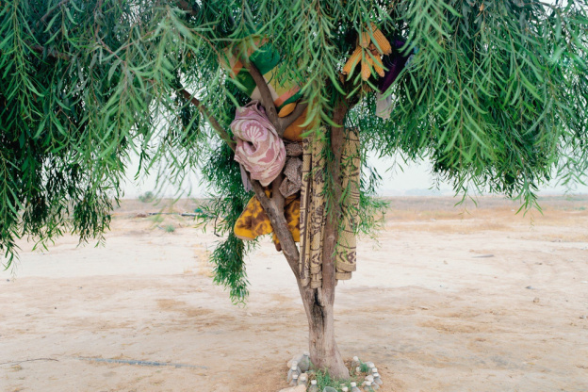
Ron Amir, Bisharah and Anwar’s Tree, 2015

The Musée d’Art Moderne de la Ville de Paris presents the exhibition Quelque part dans le désert/Somewhere in the Desert by Israeli photographer Ron Amir.
Already shown at the Israel Museum in Jerusalem in 2016, the exhibition – 30 large-format colour photographs and 6 videos – looks at the living conditions of Sudanese and Eritrean refugees in the Holot detention centre in the Negev Desert, which has since been shut down. In flight from terrorism and oppression in their home countries, these migrants were not able to live or work legally in Israel. While allowed to come and go freely during the day, they had to check in and out each morning and evening.
Dating from 2014–2016, Ron Amir’s photographs document the refugees’ daytime activities, showing how, in the desert and with no resources, they set about shaping a shared everyday existence. Using sticks, sand, stones and all kinds of abandoned bits and pieces, they managed to to put together community huts, tearooms, sporting facilities, improvised ovens and other additions to the spartan facilities provided at Holot.
We don’t actually see the refugees in the photographs: instead Amir conveys indirectly but clearly their sensitivity, creativity, and instinct for survival. Lingering over what at first glance looks like a landscape, we discover eloquent testimony to a patient waiting for freedom, to togetherness and to the hope of finding a home.
One of the things that mark out Amir’s work is his active involvement in the lives of the –as a rule socially marginalised – communities he photographs. His initial visits toHolot had no particular purpose apart from getting to know the asylum seekers. From the outset, though, the boundaries between art and political action began to blur, and in contrast with traditional documentary and press photography, Amir’s images carry several messages at the same time. Speaking of communal distress while revealing the prolific inventiveness of its victims, they are both chronicle and metaphor.

