Reviews

In Israel, Artists Engage With East African Immigration and Netanyahu’s Southern Wall
Artists react to the crisis with poignant tributes.
Hili Perlson, February 14, 2017
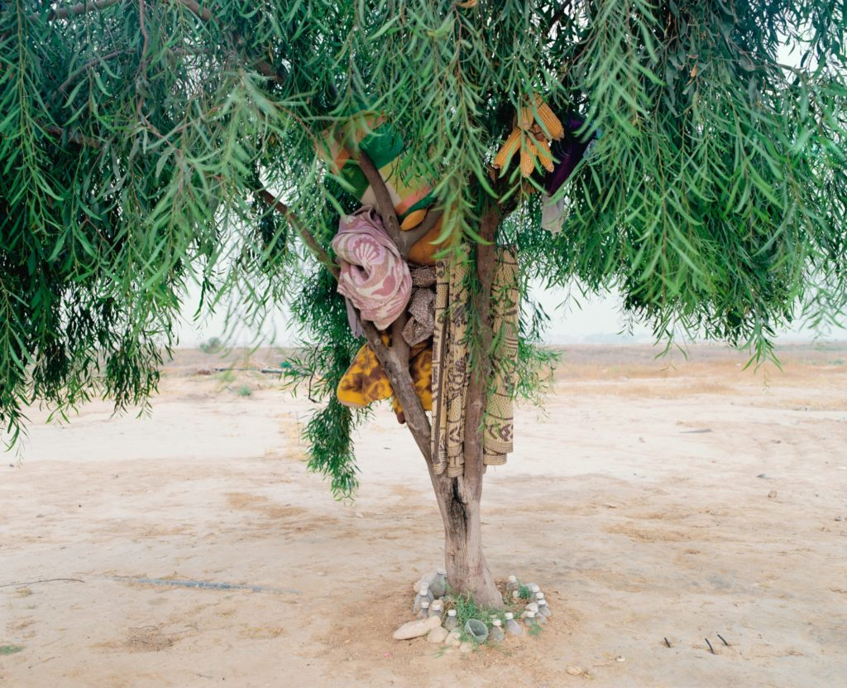Ron Amir, Bishara and Anwar's tree (2015). Courtesy The Israel museum, Jerusalem
When Israeli prime minister Benjamin Netanyahu sent out a tweet praising Trump’s plan to build a wall along the US-Mexico border, he didn’t expect the backlash that would ensue, or Mexico’s no-nonsense reaction. Sent from his personal account, the tweet—which was shared 40,000 times—read “President Trump is right. I built a wall along Israel’s southern border. It stopped all illegal immigration. Great Success. Great idea.”
The “wall” Netanyahu was referring to is a steel fence, replete with cameras and motion detectors, that Israel completed along the border with Egypt in 2013, mainly to keep out migrants and asylum seekers fleeing civil wars and conflicts in east Africa since the 2000s, including Somalis, Sudanese, and Eritreans.
Currently, tens of thousands of refugees and asylum seekers are denied recognition by the Israeli state, and live in legal limbo in communities gathered mostly around the south of Tel Aviv and southern Israel, or detained in a jail-like center. Here are some exhibitions currently on view in Jerusalem and Tel Aviv that engage with the policies of the Israeli state of handling this humanitarian crisis:
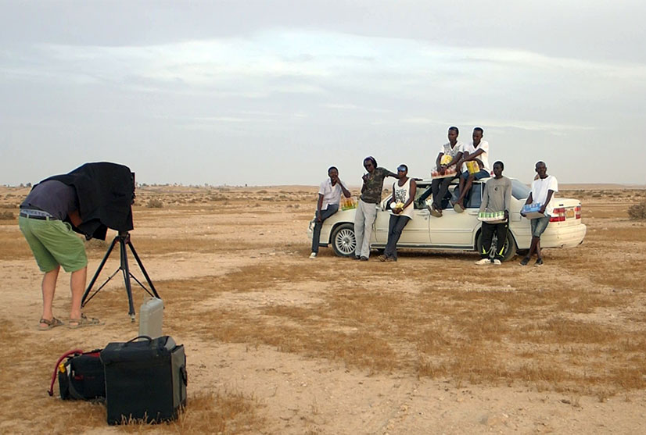
Ron Amir, Don’t Move (2015). Courtesy The Israel museum, Jerusalem
1. Ron Amir, “Doing Time in Holot,” at the Israel Museum, Jerusalem
Holot is a detention facility in the Israeli Negev desert, where thousands of Sudanese and Eritrean asylum seekers are held while awaiting their status to be processed. Israel refuses to grant them refugee status, yet it cannot deport them to their native countries as their lives could be at threat. Detainees are thus stuck in a double limbo, legal and physical: though permitted to leave the facility every morning, failing to be counted between 10 p.m. and 6 a.m. could land them at the nearby prison.

Over 3,000 men and women exit the facility into the vast Negev desert each day. Israeli photographer and video artist Rom Amir has documented, over the past couple of years, the traces of lives lived passing time in the arid landscape around Holot. Evidence of temporary, ingenious structures folded up overnight and unpacked again every morning show a system of make-do solutions: A carpet laid under a tree functions as a “café,” a pit in the sand becomes an oven, a rectangle of rocks on the ground marks the area designated as a mosque.
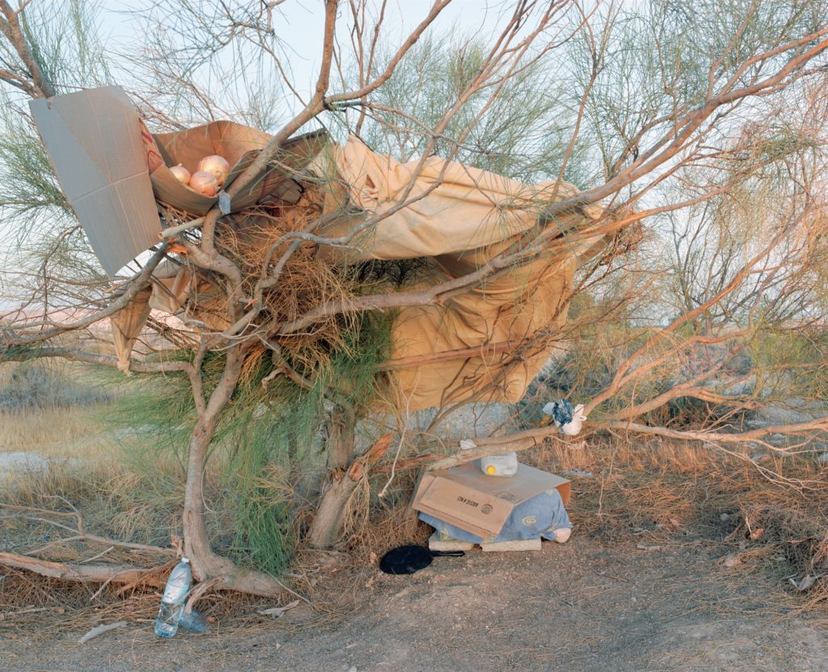
Ron Amir, Kitchen, front view (2015). Courtesy The Israel museum, Jerusalem
An outsider to a community whose social structures he grew to know through his engaged artistic work, Amir is aware of his position of privilege, both as an artist, and a free man. Thus, many of the works speak of a precariousness—of relationships, structures, lives. Not always knowing himself what the seemingly haphazard collection of branches, stones, plastic bottles, and textiles that he encounters serve as, some of the photographs in the exhibition end up highlighting the sculptural qualities of these sites as well as their social ones.
Working with a long-exposure camera, one video placed at the entrance to the exhibition clocks in at nearly 20 minutes. Showing the artist taking a portrait of a group of men, he asks them not to move for the entire duration. Time stretches under the punishing desert sun, but that’s the least of their problems.

Top of Form
Bottom of Form

